http://starbulletin.com/1999/08/09/millennium/story4.html
Dark Side of Paradise
Monday, August 9, 1999

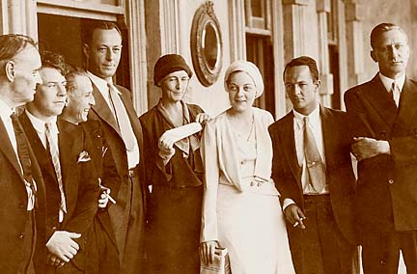
On May 4,1932, free after serving a one-hour 'prison term' for killing Joe Kahahawai, the four defendants and their lawyers appear outside Iolani Palace. From left, Attorney Clarence Darrow; defendants E.J. Lord and A.O. Jones; High Sheriff Gordon Ross; defendants Grace
Fortescue and Lt. Thomas Massie, flanking Thalia Massie; and attorney George Leisure.
Dark times cloud a land of sunshine
A 1924 labor strike turns deadly, and a sensational 1931 murder case stirs calls for military rule
By Richard Borreca
Star-Bulletin

NO one today knows who held the spark that ignited the fight. But when the day of Sept. 9, 1924, was done, 16 Filipino strikers and four police officers were dead in a camp in Hanapepe, Kauai. It was the bloodiest event in a period of growing tension.

If Hawaii was to be a melting pot, the period from 1920 to 1941 was a seething caldron. Simmering beneath Hawaii's sunny image, three major forces were at work: Economic control by the dominant "Big Five" firms, racism which exploded with the Massie case, and an increasingly powerful U.S. military presence.

Times had changed from 1911 when journalist Ray Stannard Baker wrote: "I have rarely visited any place where there was as much charity and as little democracy as in Hawaii."

For the disenfranchised, democracy would come via the labor movement supported by immigrant laborers and native Hawaiians. The bloody battle of Hanapepe resulted in the government's working with sugar planters to arrest, imprison and deport the Kauai strike organizers.

"It was a clear-cut demonstration of what would happen to any dissident workers who resorted to violence," Theon Wright said in his book, "The Disenchanted Isles."

The National Guard moved onto Kauai, and the plantations backed the purchase of riot guns, special shotguns outfitted with bayonets, said William Puette, executive director of the Hawaii Center for Labor Education and Research.

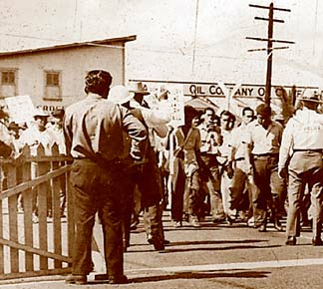
Star-Bulletin file photo
The 1938 Hilo strike ended in violence, as shown in the top two photos: first, police warn picketers against advancing on the wharf.

Those guns, bought after the Kauai massacre, would be used in 1938 when workers from nine different unions banded in Hilo. With Inter-Island Steamship Company workers on strike, goods were not reaching the Big Island port town. And when the company put the ship Waialele back into service with a crew of strike-breakers, it was a direct challenge to the unions.

Longshoremen vowed to picket, as the sheriff promised merchants county protection. While the unarmed strikers pledged nonviolence, police officers armed themselves with tear gas, the riot guns and Thompson submachine guns.

As the Waialele pulled into the tense port, one deputy sheriff charged the crowd, clubbing and stabbing strikers -- and police opened fire. Fifty-one people went to the hospital, most with wounds in the back, sustained while running from the police. One strike leader was permanently crippled.

The battle for labor rights was dramatic, but it was merely one aspect of Hawaii's new uneasiness. "The political economy of Hawaii was moving rapidly toward a polarization of its population . . . it was the planters' insistence upon total control over the work force with regard to even elementary rights accorded by a democratic society," said labor historian Ed Beechert.
Hawaii, as it grew prosperous, had become a locked-up company town.

"The Big Five was really the Big One: there was a very small group of people who were on everybody's board," said Puette. The five firms: Alexander & Baldwin, American Factors, C. Brewer & Co., Castle & Cooke, and Theo H. Davies, Ltd.

In 1940, on orders from the newly formed National Labor Relations Board, Elwyn Eagen reported to the U.S. Congress on the labor situation in Hawaii.

Talking about the industrialists, Eagen said: "Their absolute control and domination of the lives and welfare of virtually every individual in the Island is such that, had not their actions been somewhat tempered by some regard for the rights of human beings, the picture would be far darker."

"Persons who do not comply with the wishes of the Big Five," he said, "are refused loans or extensions and are forced out of business."

Eagen added: "An attorney who takes a case against the interests of the Big Five soon learns that he cannot stay in business."

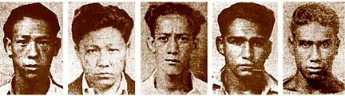
Star-Bulletin file photos
The five charged in Thalia Massie's alleged rape were, from left, David Takai, Horace Ida, Henry Chang, Benny Ahakuelo and Joe Kahahawai, who was killed.

Racial tensions explode

Racism, another tension spun from the changing dynamics in Hawaii's population, was also ready to explode. And it did, in the Massie case.

The case captured it all: the racial mistrust, the heavy hand of the military, the quick alignment of the controlling political and economic powers.

Just before midnight on Sept. 12, 1931, a dark night with a tiny new moon, 20-year-old Thalia Massie, socialite wife of Navy Lt. Thomas Massie, left a dance at the Ala Wai Inn in Waikiki. Walking alone on Ena Road, Massie said, she was forced into a car by two men. She was punched in the face and assaulted, then dumped off at Ala Moana, she claimed.

Five local men were charged with rape: Horace Ida, Henry Chang, Benjamin Ahakuelo, David Takai and Joseph Kahahawai. Newspaper reports described Massie as "a white woman of culture and refinement."

Amid defense theories that Lt. Massie had beaten Thalia after finding her with another Navy officer, and allegations that police had put Massie's purse in the suspects' car, the jury failed to reach a verdict.

Honolulu erupted.

One of the defendants, Ida, was kidnapped and whipped by a mob. At least eight riots were reported, as the military seethed at the civilian rule. The Honolulu Star-Bulletin reported: "Groups of men, clad in dungarees, launched pitched battles in various sections of the city with civilian gangs."

Adm. George Pettingill telegraphed Washington, D.C., that Honolulu was not a safe place for wives and families.

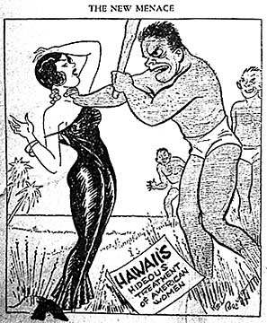Star-Bulletin file
On Feb. 1, 1932, this made the front page of Brevities, a New York publication calling itself "America's First Tabloid Weekly.

The mainland press saw the incident as a threat to whites. One paper said: "Yellow men's lust for white women had unbroken bounds. A tremor of apprehension ran through Honolulu's motley population -- coolies from China, great Russians from Siberia and little Japanese . . ."

On Jan. 8, as defendant Kahahawai exited court after his daily check-in, he was kidnapped by Thomas Massie; Thalia's mother,Grace Fortescue (niece of inventor Alexander Graham Bell), and a sailor. They took Kahahawai to Fortescue's rented Manoa home, where they beat him and demanded his confession. When none came, Thomas Massie picked up a gun and put it to Kahahawai's chest. In court testimony later, Massie claimed he didn't remember what happened next.

Kahahawai was found dead in the trunk of their car in East Oahu, shot in the chest. All three, plus another sailor arrested the next day, were charged with murder.

The Massie case in the press
'It is an entirely plain matter that there must be an investigation and an overhauling of governmental affairs in Hawaii. Police control had undoubtably grown corrupt. The condition of violence and hoodlum rule, which eventuated in certain social outrages of a frightful character, grew out of want of control of this seething hoodlum element. Certain juries in the territorial courts consisting largely of natives are unreliable as was proven by the leniency shown in the case of the hideous criminals involved in the outrage upon Mrs. Massie, a young naval officer's wife.'
-- Boston Transcript
Excerpt from its news editorial

'Here lies a very great opportunity for (President Herbert) Hoover. He should remove the weakling Governor (Lawrence) Judd, his appointees, declare martial law in the Territory of Hawaii and appoint as its administrator the local commanding officer of the Army, who is said to have a full division on the spot, to enforce it. (The late President Theodore) Roosevelt would have done it on Sept. 13, instead of waiting until the present shameful state of affairs had developed.'
-- New York Evening Post
Excerpt from an editorial

The grand jury, however, did not want to indict the four. In a show of judicial independence, Territorial Judge A.M. Cristy entered the grand jury room and lectured jurors about racism, recalled Hawaii's present Chief Justice, Ronald Moon. "The grand jury was very concerned with the opinions of the naval commander, who indicated that the young boys were let off the hook," Moon said.

But Cristy told the jury it must be concerned only with the facts: "I ask you gentlemen to lay aside all race prejudices and rise above all trivial, personal considerations and apply yourself to the question of whether this government shall exist and how."

Famed defense attorney Clarence Darrow arrived to defend the four. Mainland newspapers rushed to cover the trial -- and howled for action, saying the defendants were being tried unjustly. Some called for President Herbert Hoover to get involved.

The New York Evening Post, for instance, recommended a "U.S. battleship pull the four out of Hawaii and that Gov. (Lawrence) Judd be removed and place the islands under martial law."

The cry to put Hawaii under military rule continued when the four were convicted of manslaughter and sentenced to 10 years in prison. But in a final bit of injustice, Judd commuted the sentence of the killers to one hour, to be served under the supervision of the Hawaii High Sheriff.

The Territory escaped martial law then. But just nine years later, at the start of World War II, Hawaii would be the first piece of American soil since the Civil War to be stripped of the Constitution and the Bill of Rights, and to be run by the military.

© 1999 Honolulu Star-Bulletin
http://starbulletin.com

